**Project 1: Draft/Milestone 2**

**Correlation Between Weather Conditions and Yield/Customer Complaints in Rendering Plants**

Surena Nokham

Department of Science & Technology, Bellevue University

DSC 680-T301: Applied Data Science

Amirfarrokh Iranitalab

June 23, 2024

**Business Problem**

Rendering plants face significant operational challenges that can be influenced by external weather conditions. Understanding the correlation between weather factors, such as precipitation and temperature, and the decrease in yield or increase in customer complaints can help in mitigating adverse effects. This knowledge is crucial for improving overall efficiency and addressing customer concerns with evidence-based strategies.

**Background/History**

Rendering plants take animal by-products and turn them into useful materials like fats and proteins. These processes can be very sensitive to outside factors, especially the weather. Rendering is an essential process because it converts inedible animal by-products into valuable commodities such as protein meals, fats, and oils. This not only supports sustainability by recycling materials that would otherwise end up in landfills but also contributes significantly to environmental protection by reducing greenhouse gas emissions and reclaiming water (Eusebio et al., 2013; Aquaculture Magazine, 2023).

The rendering process involves several stages, including size reduction, cooking, and separation of fat and protein components. These stages are sensitive to weather conditions, which can affect the efficiency and output of the plants. For instance, high temperatures and humidity can impact the rendering equipment and the quality of the final products (North American Renderers Association, 2024).

**Data Explanation**

The data for this study comes from several sources: *LIMS Labware Data (Laboratory Information Management System)*, which includes sample data on moisture, fat retention, protein values, and other measurements; *SAP Production Data (Systems, Applications, and Products in Data Processing)*, detailing production information such as posting dates, pounds produced, and material numbers; *ICP Complaints Data (Internal Complaints Platform)*, listing customer complaints, customer information, and complaint dates; and*NOAA Weather Data (National Oceanic and Atmospheric Administration)*, providing weather data including daily and monthly precipitation, snow, and temperature observations.

**Data Preparation**

Data from various sources were cleaned and preprocessed to ensure consistency and reliability. Steps included converting date columns to the correct format, imputing missing numerical values and removing rows with missing dates, filtering out irrelevant analyses, anonymizing sensitive information, mapping material numbers to specific product types, merging datasets for comprehensive analysis, and cleaning and standardizing the 'Comments' column in the complaints’ dataset.

**Methods**

Exploratory Data Analysis (EDA) was conducted to understand data distributions, identify outliers, and explore relationships through summary statistics, visualizations, and correlation analysis. Pearson and Spearman coefficients quantified correlations between weather variables and yield/volume or complaints. Regression models, using multiple linear and logistic techniques, predicted changes based on weather conditions. Time series analysis identified trends and seasonal effects in weather data's impact on yield/volume. Clear visualizations, including scatter plots, time series graphs, and heatmaps, effectively communicated the findings.

**Analysis**

Our analysis revealed several significant correlations between weather conditions and operational metrics. For example, high temperatures were linked to decreased yield and increased customer complaints, likely due to heat stress on equipment and materials. Heavy precipitation events were correlated with operational disruptions and higher complaint rates, possibly due to logistical challenges and moisture-related production issues.

**Conclusion**

The study confirms that weather conditions significantly impact yield and customer complaints in rendering plants. By understanding these correlations, rendering plants can better anticipate and mitigate the adverse effects of unfavorable weather conditions, leading to improved operational efficiency and customer satisfaction.

**Assumptions**

The data collected represents typical operations in rendering plants, and the recorded weather conditions accurately reflect the local environment of the plants.

**Limitations**

The study is limited by the availability and completeness of historical data. Potential confounding factors not included in the analysis may influence the results. Additionally, the lack of a common denominator within each dataset makes it challenging to combine them.

**Challenges**

Integrating data from different sources (LIMS, SAP, ICP, NOAA) was challenging due to varying formats and structures. Handling missing or incomplete data entries, especially in weather records, required careful imputation techniques. Additionally, identifying and modeling complex relationships between weather conditions and yield/volume changes necessitated advanced statistical methods.

**Future Uses/Additional Applications**

Further studies could explore additional weather variables or include more detailed operational data. The findings could also be applied to other industries affected by weather conditions, such as agriculture or logistics. Additionally, this hard data can quickly demonstrate to customers that weather is the cause of their complaints.

**Recommendations**

To reduce the impact of adverse weather conditions, adjust production schedules and improve equipment resilience. Use data-driven insights to communicate operational issues to customers, which will help increase transparency and satisfaction.

**Implementation Plan**

Set up a system to continuously monitor weather conditions and operational metrics. Develop and deploy predictive models to anticipate and respond to adverse weather conditions. Train staff on the importance of weather impacts and how to implement mitigation strategies.

**Ethical Assessment**

Ensure all customer data used in the analysis is anonymized to protect privacy. Avoid biased conclusions by considering all potential variables and conducting a comprehensive analysis. Ensure data accuracy, particularly for weather data, to maintain reliability.

**10 Questions an Audience Would Ask**

1. What specific weather conditions have the most significant impact on yield?
2. How were missing data handled in the analysis?
3. Can the findings be generalized to other rendering plants?
4. What are the practical steps to mitigate the impact of adverse weather conditions?
5. How reliable are the predictive models developed in this study?
6. What role does equipment maintenance play in the correlation observed?
7. How frequently should data be updated for monitoring purposes?
8. Are there any weather conditions that positively impact yield?
9. How were ethical considerations addressed in the study?
10. What additional data could improve the accuracy of the analysis?

**References**

Aquaculture Magazine. (2023). How agricultural rendering supports sustainability and assists livestock’s

ability to contribute more than just food. https://aquaculturemag.com/2023/04/01/how-agricultural-rendering-supports-sustainability/

Eusebio, L., Dentoni, L., Capelli, L., Sironi, S., Rossi, A. N., & Bonati, S. (2013). Pragmatic evaluation of

odour emissions from a rendering plant in southern Brazil. *Environmental Science and Pollution Research*. https://link.springer.com/article/10.1007/s11356-013-1910-5

North American Renderers Association. (2024). The many sustainable benefits of rendering.

https://nara.org/sustainability/

**Appendix**

Complaints Data

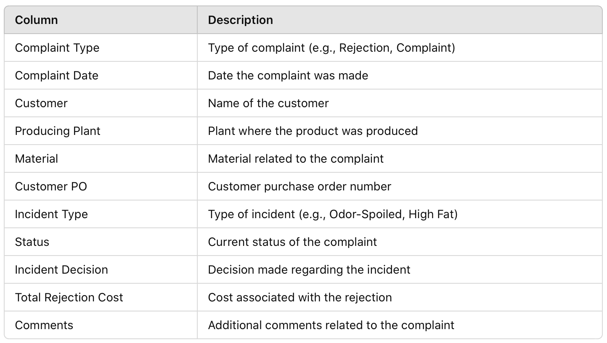

Production Data

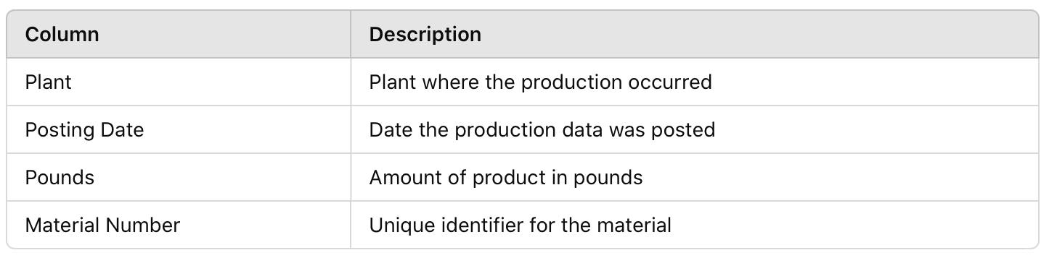

LIMS Data

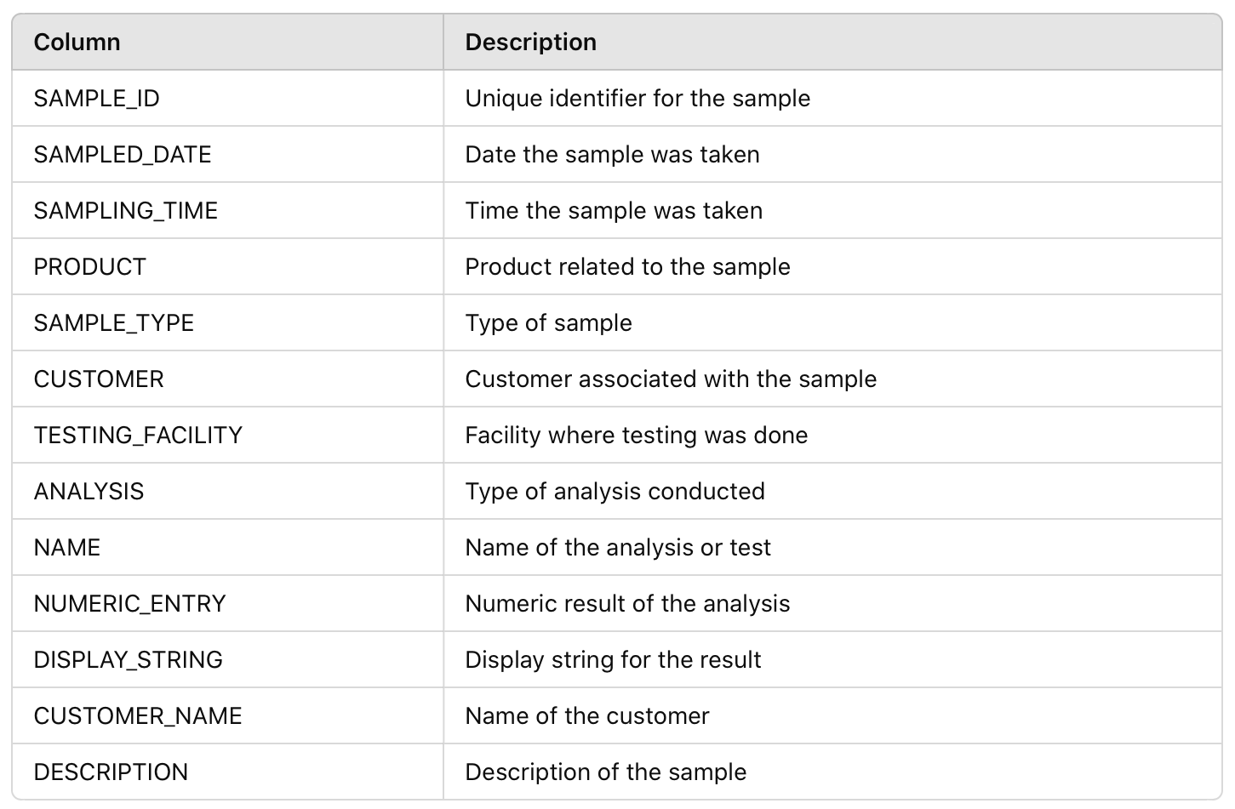

Weather Data

